Pizza Sales SQL Queries
KPIS
-- TOTAL REVENUE
SELECT SUM(total_price)
AS Total_Revenue FROM pizza_sales
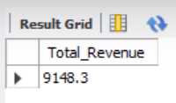
--Average Order Value
SELECT SUM(total_price) / COUNT(DISTINCT order_id) AS avg_order_value
FROM pizza_sales
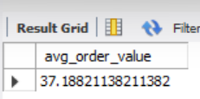
-- Total Pizza sold
SELECT SUM(quantity) AS Total_Pizza_Sold FROM pizza_sales
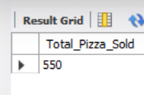
-- Total Orders Placed
SELECT COUNT(DISTINCT order_id) AS Total_Orders FROM pizza_sales
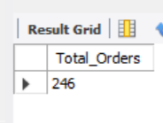
-- Average Pizzas Per Order
SELECT CAST(CAST(SUM(quantity) AS DECIMAL (10,2)) / CAST(COUNT(DISTINCT order_id)
AS DECIMAL (10,2)) AS DECIMAL (10,2)) AS Avg_Pizza_Per_Order FROM pizza_sales
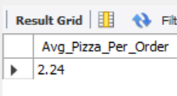
Chart Requirements
-- Daily Trend For Total Orders
SELECT DAYNAME(order_date) AS order_day,
COUNT(DISTINCT order_id) AS total_orders
FROM pizza_sales
GROUP BY DAYNAME(order_date)
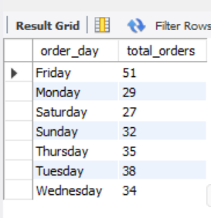
-- % of Sales by Pizza Category
SELECT pizza_category, CAST(SUM(total_price) AS DECIMAL(10,2)) as total_revenue,
CAST(SUM(total_price) * 100 / (SELECT SUM(total_price) from pizza_sales) AS DECIMAL(10,2)) AS PCT
FROM pizza_sales
GROUP BY pizza_category
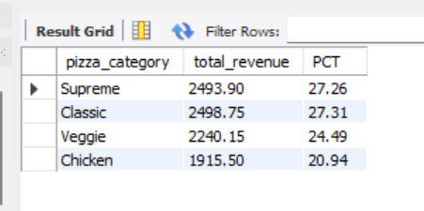
-- % of Sales by Pizza Size
SELECT pizza_size, CAST(SUM(total_price) AS DECIMAL(10,2)) as total_revenue,
CAST(SUM(total_price) * 100 / (SELECT SUM(total_price) from pizza_sales) AS DECIMAL(10,2)) AS PCT
FROM pizza_sales
GROUP BY pizza_size
ORDER BY pizza_size
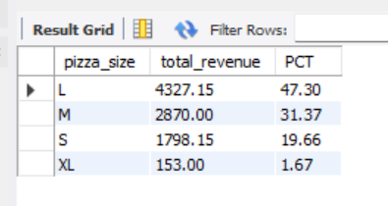
-- Total Pizzas Sold by Pizza Category
SELECT pizza_category, SUM(quantity) as Total_Quantity_Sold
FROM pizza_sales
WHERE MONTH(order_date) = 2
GROUP BY pizza_category
ORDER BY Total_Quantity_Sold DESC
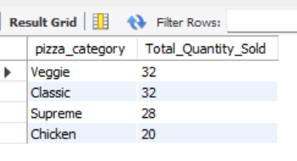
-- Top 5 Pizzas by Revenue
SELECT pizza_name, SUM(total_price) AS Total_Revenue
FROM pizza_sales
GROUP BY pizza_name
ORDER BY Total_Revenue DESC
LIMIT 5;
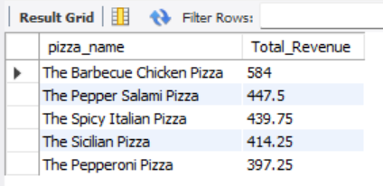
-- Bottom 5 Pizzas by Revenue
SELECT pizza_name, SUM(total_price) AS Total_Revenue
FROM pizza_sales
GROUP BY pizza_name
ORDER BY Total_Revenue ASC
LIMIT 5;
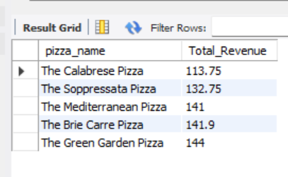
-- Top 5 Pizzas by Quantity
SELECT pizza_name, SUM(quantity) AS Total_Pizza_Sold
FROM pizza_sales
GROUP BY pizza_name
ORDER BY Total_Pizza_Sold DESC
LIMIT 5;
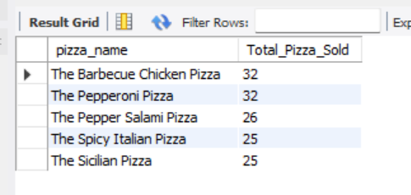
-- Bottom 5 Pizzas by Quantity
SELECT pizza_name, SUM(quantity) AS Total_Pizza_Sold
FROM pizza_sales
GROUP BY pizza_name
ORDER BY Total_Pizza_Sold ASC
LIMIT 5;
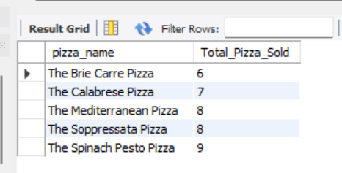
-- Top 5 Pizzas by Total Orders
SELECT pizza_name, COUNT(DISTINCT order_id) AS Total_Orders
FROM pizza_sales
GROUP BY pizza_name
ORDER BY Total_Orders DESC
LIMIT 5
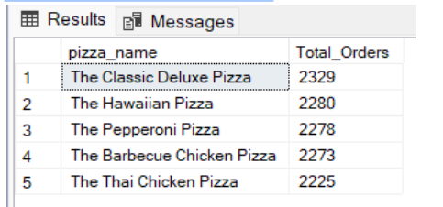
-- Bottom 5 Pizzas by Total Orders
SELECT pizza_name, COUNT(DISTINCT order_id) AS Total_Orders
FROM pizza_sales
GROUP BY pizza_name
ORDER BY Total_Orders Asc
LIMIT 5
